**Kubeadm commands:**

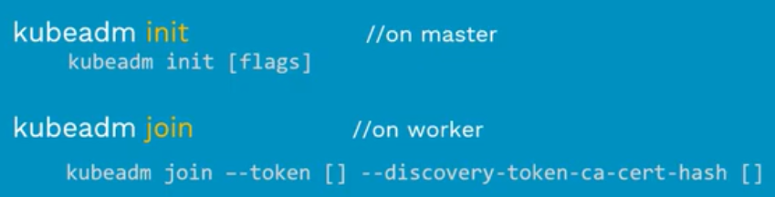

* Init command is used to install the master node
* Join command is used to add the worker nodes to the master.

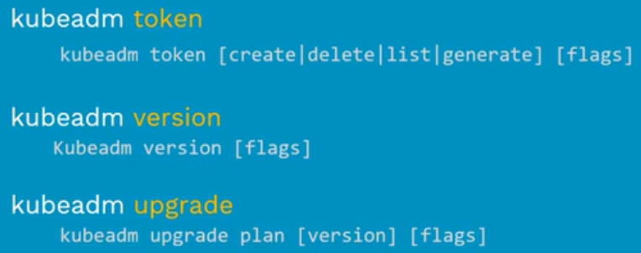

* Version command is used to check the version of cluster.
* Upgrade command is used to upgrade or downgrade the cluster.
* These are the most used kubeadm commands.

**pre-requisites:**

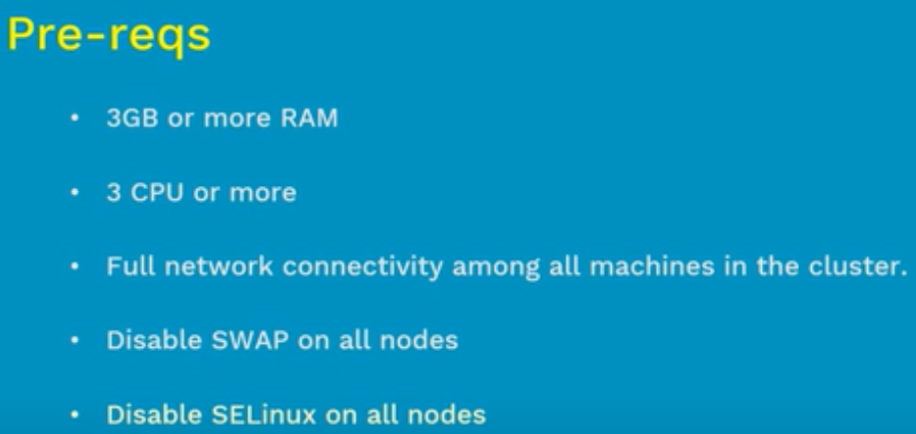

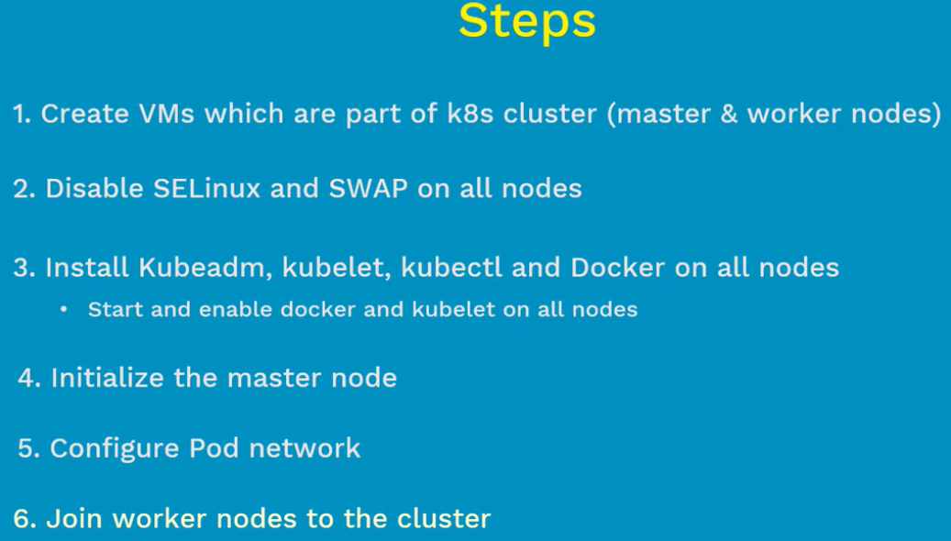

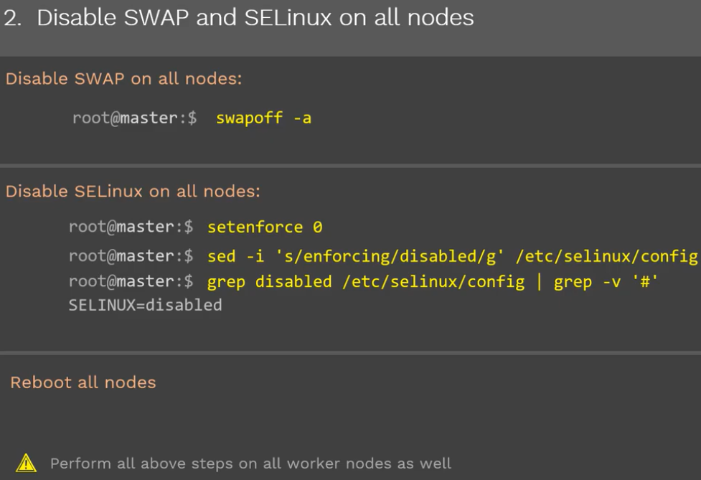

* Disabling SWAP is to increase the performance of a server.

**Installing docker:**

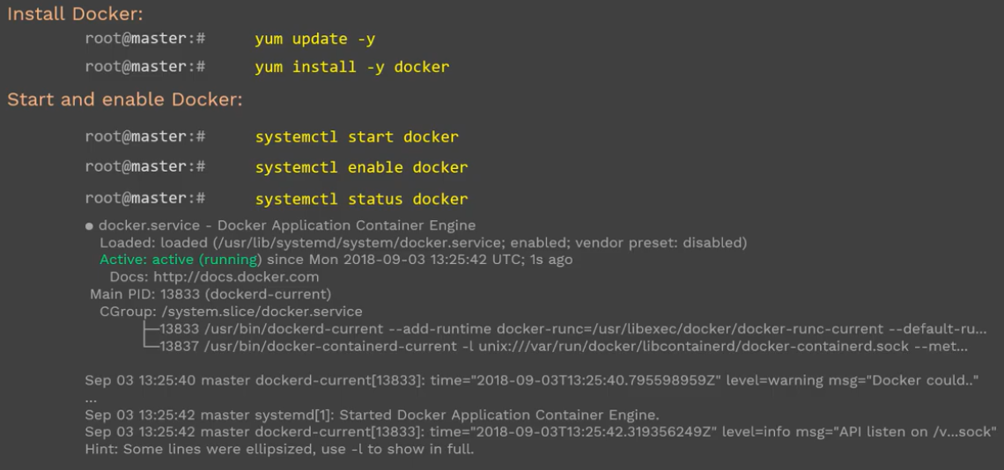

* In next step, we need to install docker in all the servers including master.

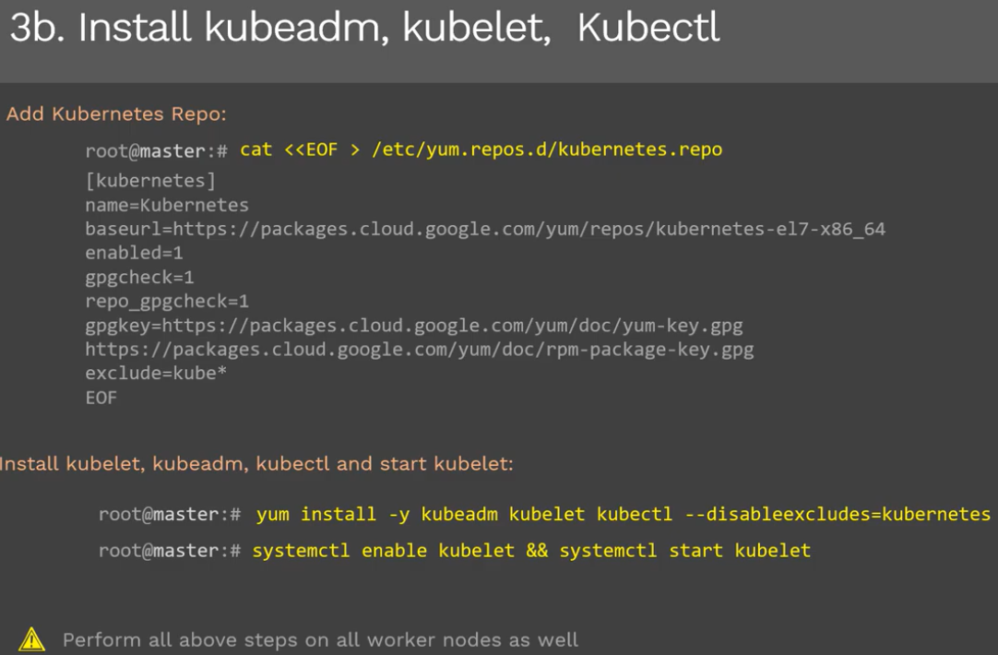

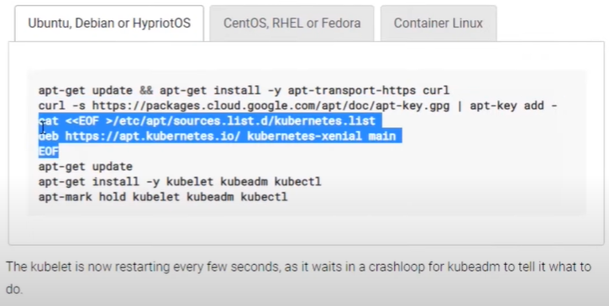

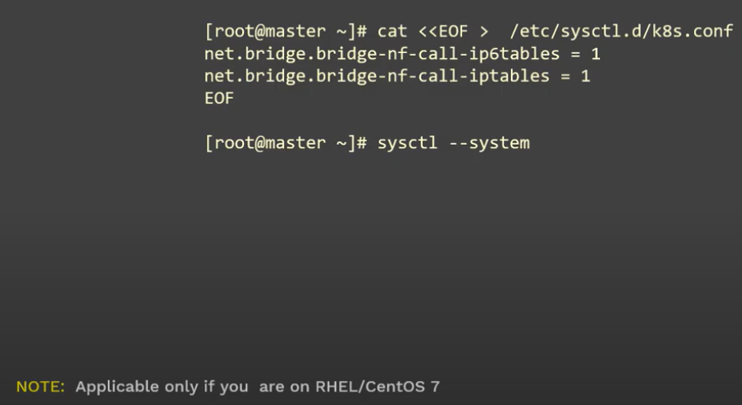

* We also need to install kubeadm, kubelet and kubectl in all the servers.
* Kubernetes is installed with these steps. We need to initialize master node now.

**Initializing master node:**



* As above, we need to run kubeadm init command to initialize master node. We can give the private IP as above and mention CIDR block for the POD networking in the cluster.
* Below are the network plugins to Kubernetes to maintain the POD networking.

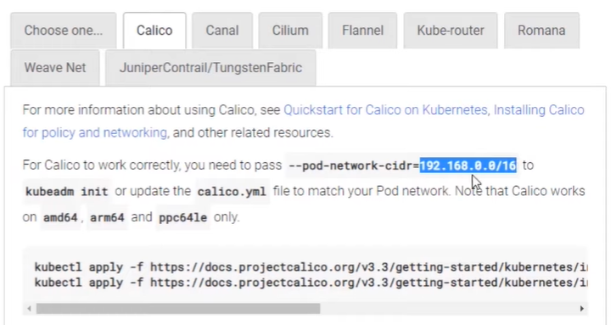

* We should use the highlighted CIDR range only if we use **“calico”** plugin.
* We may get the below warning while running this command if the master node doesn’t meet the prerequisites.

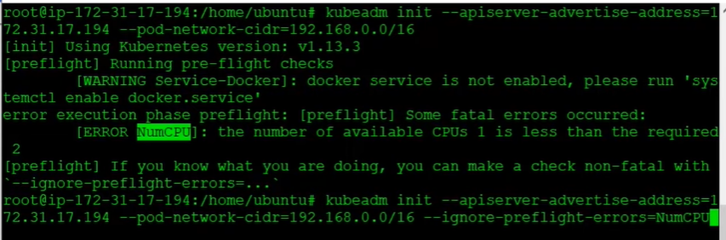

* We can ignore that warning message by passing **“—ignore-preflight-errors”** as above.

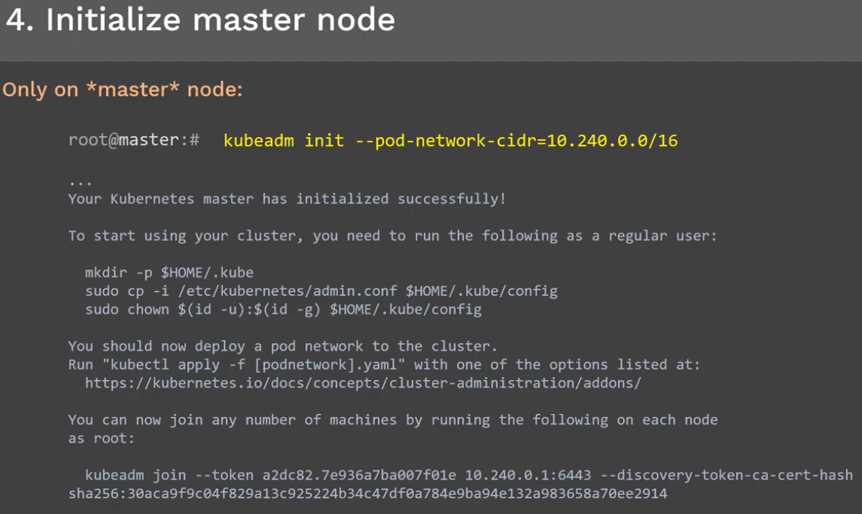

**Join the nodes:**

* Once we initialize the master node as above. It will give us the join command in output as below.
* We need to run the above 3 commands for kubectl to work

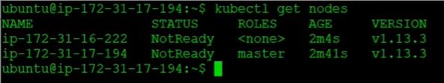

* As we see, the nodes are not ready even after running the join command. It’s because we haven’t installed network plugin on nodes.

**Installing network plugins on nodes:**

* We need to apply network yaml files on nodes based on the plugin we are using as below

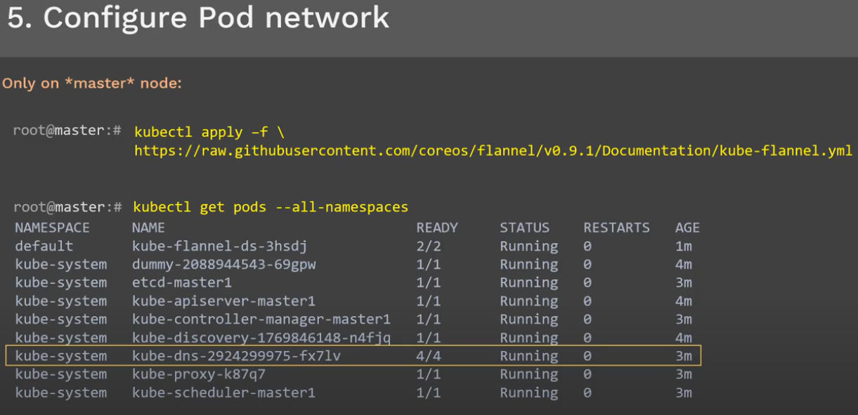

* We need to make sure we are using the correct flannel manifest file by checking in kubernetes docs.
* After this, we can see the nodes are in ready state.

Once this is all done, we can add the worker nodes to master as below.

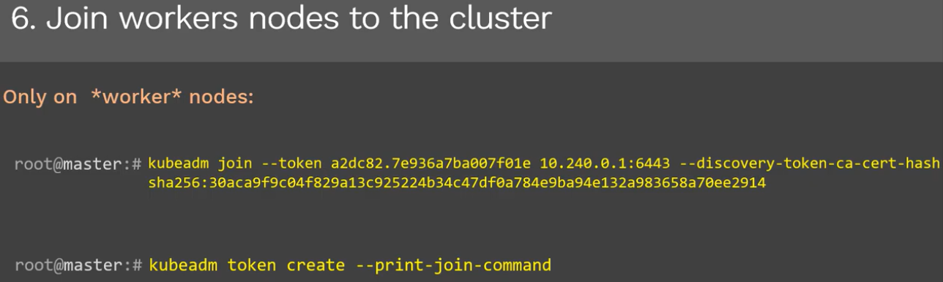

* We use the above command to join the worker node to master. The token gets expired after 24hrs. we can create it again with **“kubeadm token create”** command as above.